Material Flow Modelling and Analysis Tool

|  |  |  |
| --- | --- | --- |
|  | | |
|  | | |
|  | | |
| Introduction of the tool | |
|  |
| Date | 20 April 2017 |
|  |  |
| Author(s) | H.Zhou |

|  |  |
| --- | --- |
| Copy no. | 1 |
| No. of copies | 1 |
| Number of pages | 4 |
| Number of appendices | 0 |
| Customer | Zhuhai Gaolan Port Authority,  Guangdong Association of Circular Economy and Resources Comprehensive Utilization |
| Project name | CE(Circular Economy) Platform |
| Project number | 060.24321 |

All rights reserved.

No part of this publication may be reproduced and/or published by print, photoprint, microfilm or any other means without the previous written consent of TNO.

In case this report was drafted on instructions, the rights and obligations of contracting parties are subject to either the General Terms and Conditions for commissions to TNO, or the relevant agreement concluded between the contracting parties. Submitting the report for inspection to parties who have a direct interest is permitted.

© 2017 TNO

# Introduction

This tool is specially developed for Gaolan Port, Zhuhai, China. It is for material flow modeling and analysis.

The tool can help Gaolan port optimize the petrol chemical chain to get max product output and economic value by screening different scenarios for extension of the Gaolan petrochemical complex that adds most value (added value of products) and that does not result in large additional emissions.

The tool includes both the client side and the server side. Figure 1 shows the starting page of the tool on the client side using a modern web-browser which is the user interface. The users only interact with the client side. On the server are all the calculations, data, and a database.

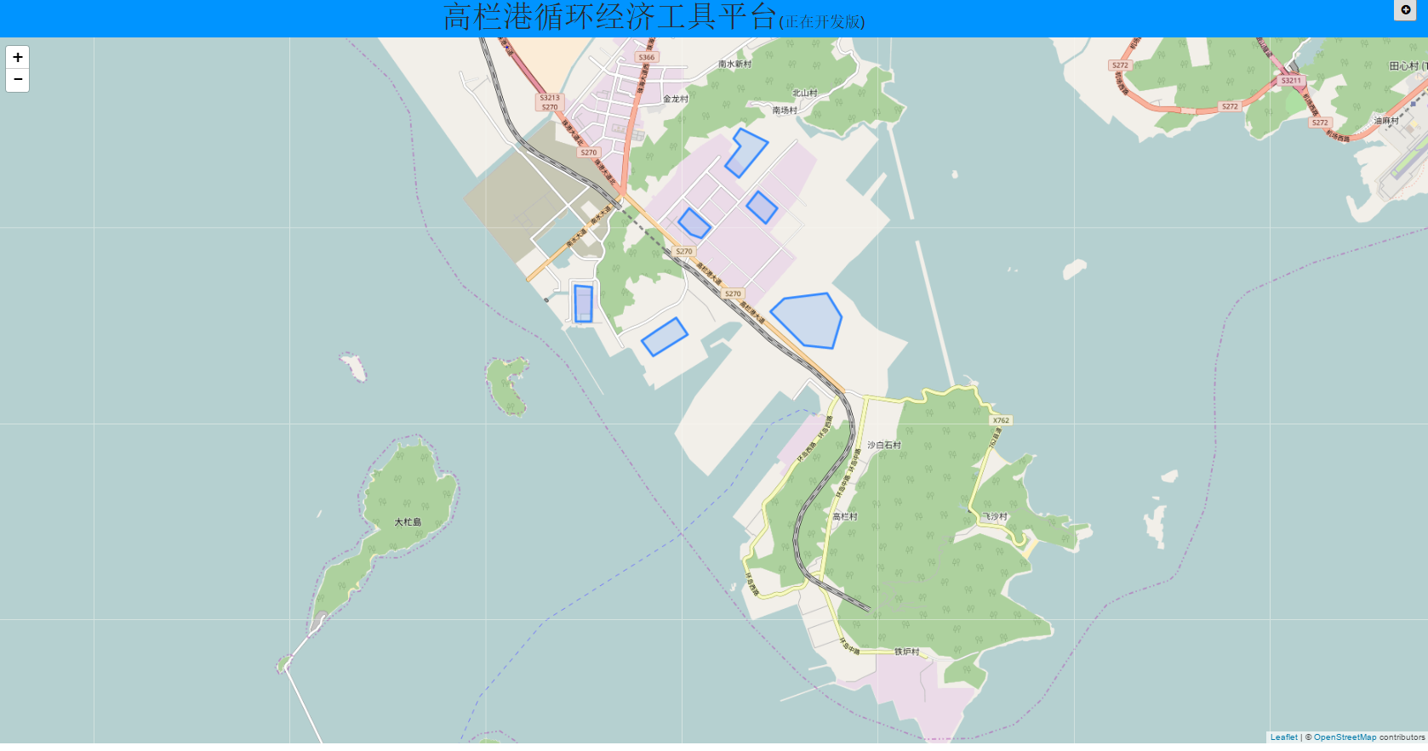

Figure 1. Tool start page

# Tool functions

In this section, the use case described what a user can do and what a user can get from the tool. The functions implemented are accepted by GDCERCU during the meeting on 10 April, 2017 in Guangzhou.

## *Functions existing*

* Per factory information about products, by-products, raw material, the emission is displayed.

**Data required:** spatial location of the plant, actual product name, and capacity

*(****all information is calculated by TNO, which is used as benchmark****)*

* Change the capacity of production or local chemical price of a factory, so that the added value will be visible. Also increased emissions and energy use corresponding with this change will be made visible. Furthermore, the upstream processes of the related process will be calculated. E.g. Increase in capacity of MEA from 1 MT/year to 10 MT/year will show an increase in margin cost and emission on the block level but also show/remark on the impact on Ethylene oxide
* Add defined process(es) to existed plants. Changes on the area will be displayed.
* Click on a product or a raw material, so that plants making use of the product or supplying the raw material will be highlighted on the map. It shows a (potential) connection between plants
* The user is able to edit the existed chemical components or insert new components into the database. This provides the platform the capability to include new components in the future. This is also necessary in order to add new chemical processes.
* TNO will create a few process blocks. Since the petrol chemical chain contains a lot of processes, it is necessary to have a function to let the user/TNO add new chemical process or edit existed chemical process. This requires the introduction of locally collected data on mass flows, reaction efficiency, energy use and emission data etc.

## *Functions to be done*

* Compare the gaolan factory performance with the benchmark, describe the reason(s) if factory performance is worse. This is the work of WP4

## Optional functions (work outside the contract)

* Create new plants by drawing a polygon on the map, then add process(es) to them, in order to simulate the situation after a new plant is working in Gaolan Area. After added, the potential whole material flow change in the area will be displayed.
* see the whole area description quantitatively within an area, so that you can show to (potential) plants.

**Data required: whole area related data including locations**

* see the petrol chemical processes connected through main feedstock / main product mass streams in a chart, in order to have an overview of the processes and plants using those processes.
* see the energy change/recycling, so that to identify the energy-related issue
* Virtual reality (no actual functions implementations)